NextField EOL to NextField Opportunity Four Discussion Items/Infographics
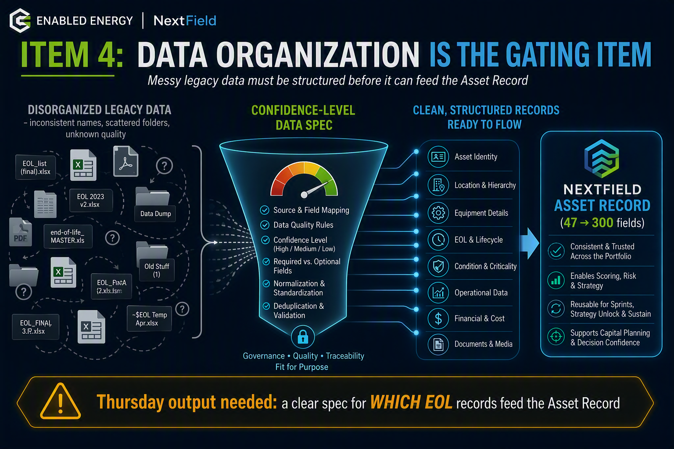 I'll create four highly detailed infographics — one for each of the four Thursday NF call items — all in EE's brand style (dark navy, lime green, sky blue, teal) for a cohesive boardroom-ready set.Here are the four boardroom-ready infographics — one for each Thursday NF call item — in a consistent EE/NextField brand style so they work as a cohesive set alongside the earlier mapping visual.
Item 1 — Proof of Concept, Not a Rebuild Shows the three source engines (9-criteria scoring, SPOF/site-risk model, $780M capital forecast) flowing into the NextField Screener and Strategy Unlock, reinforcing that the tool is already validated with real Flexential data.
Item 2 — Standing It Up = Three Work Items The three-panel build path: port the scoring into the Dataverse Asset Record, wire the forecast into Strategy Unlock capital sequencing, and rebuild the Power BI views as NextField reports.
Item 3 — Monetize the Annual Refresh Positions the yearly refresh as NextField Sustain / Portfolio Asset Intelligence Service, with the quarterly cadence and the ~$79–86K first-year recurring figure as the retention play.
Item 4 — Data Organization Is the Gating Item The funnel from messy legacy files through a confidence-level data spec into clean Asset Record fields, with the amber call-to-action for Thursday's needed output — a spec for which EOL records feed the Asset Record.
Want me to compile all five visuals (the mapping + these four) into a single PowerPoint deck with speaker notes for each slide, so you can walk Leo and Joe through it on the call? I could also add a short cover slide and a closing "asks/decisions" slide to frame the discussion.

